Michael Fitzgerald
Professor Michele Griegel-McCord
English 2089
11 December 2014
Derek Jeter: The Discourse that Created the Captain
Der-ek Jet-er *clap, clap, clap clap clap*, De-rek Je-ter *clap, clap, clap clap clap*. This cheer has spread through Yankees stadium for 20 years ever since Derek Jeter put on the Yankee pinstripes. From his rookie season when Jeter won rookie of the year, to his last plate appearance in Yankee Stadium (he hit a walk-off single to beat the Orioles), Jeter has grown a persona through his discourse and the discourses surrounding him that have earned him the nicknames “Mr. November”, “Captain Clutch”, and “the Captain”.
This image of Jeter has been a result of the many texts and discourses over Jeter’s long and illustrious career. The way the media has portrayed Jeter, and the way he has portrayed himself, have made “the Captain” into who he is today. Many people praise Jeter as a class act and great ballplayer. He has been able to appeal to these people through his on field play, interviews, TV appearances, ad campaigns, and much more. However, despite this dominating image of success and greatness portrayed in these genres listed above, there is a small population out there who says Jeter is overrated and should not be so well liked. Sources such as blogs and internet articles paint Jeter as an overrated athlete and reserved individual who doesn’t ever show us his true person. Jeter’s portrayal of himself, or lack there of in some peoples opinion, has played a huge role in keeping him a fan and media favorite. Overall, the positive discourse surrounding and created by Jeter tends to outweigh the negative discourse. This frames Jeter as a positive influence on the game of baseball.
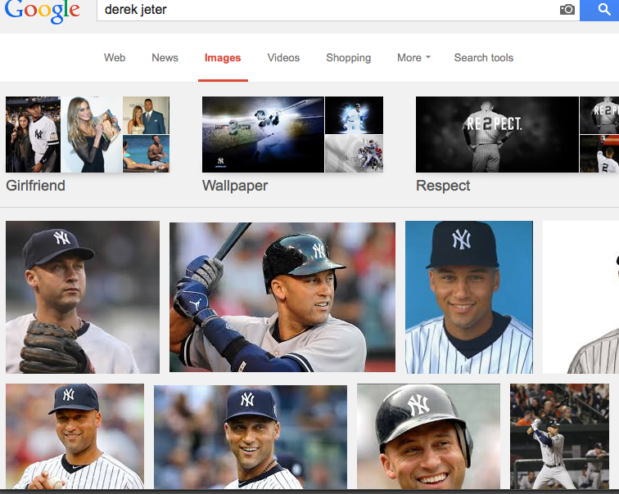
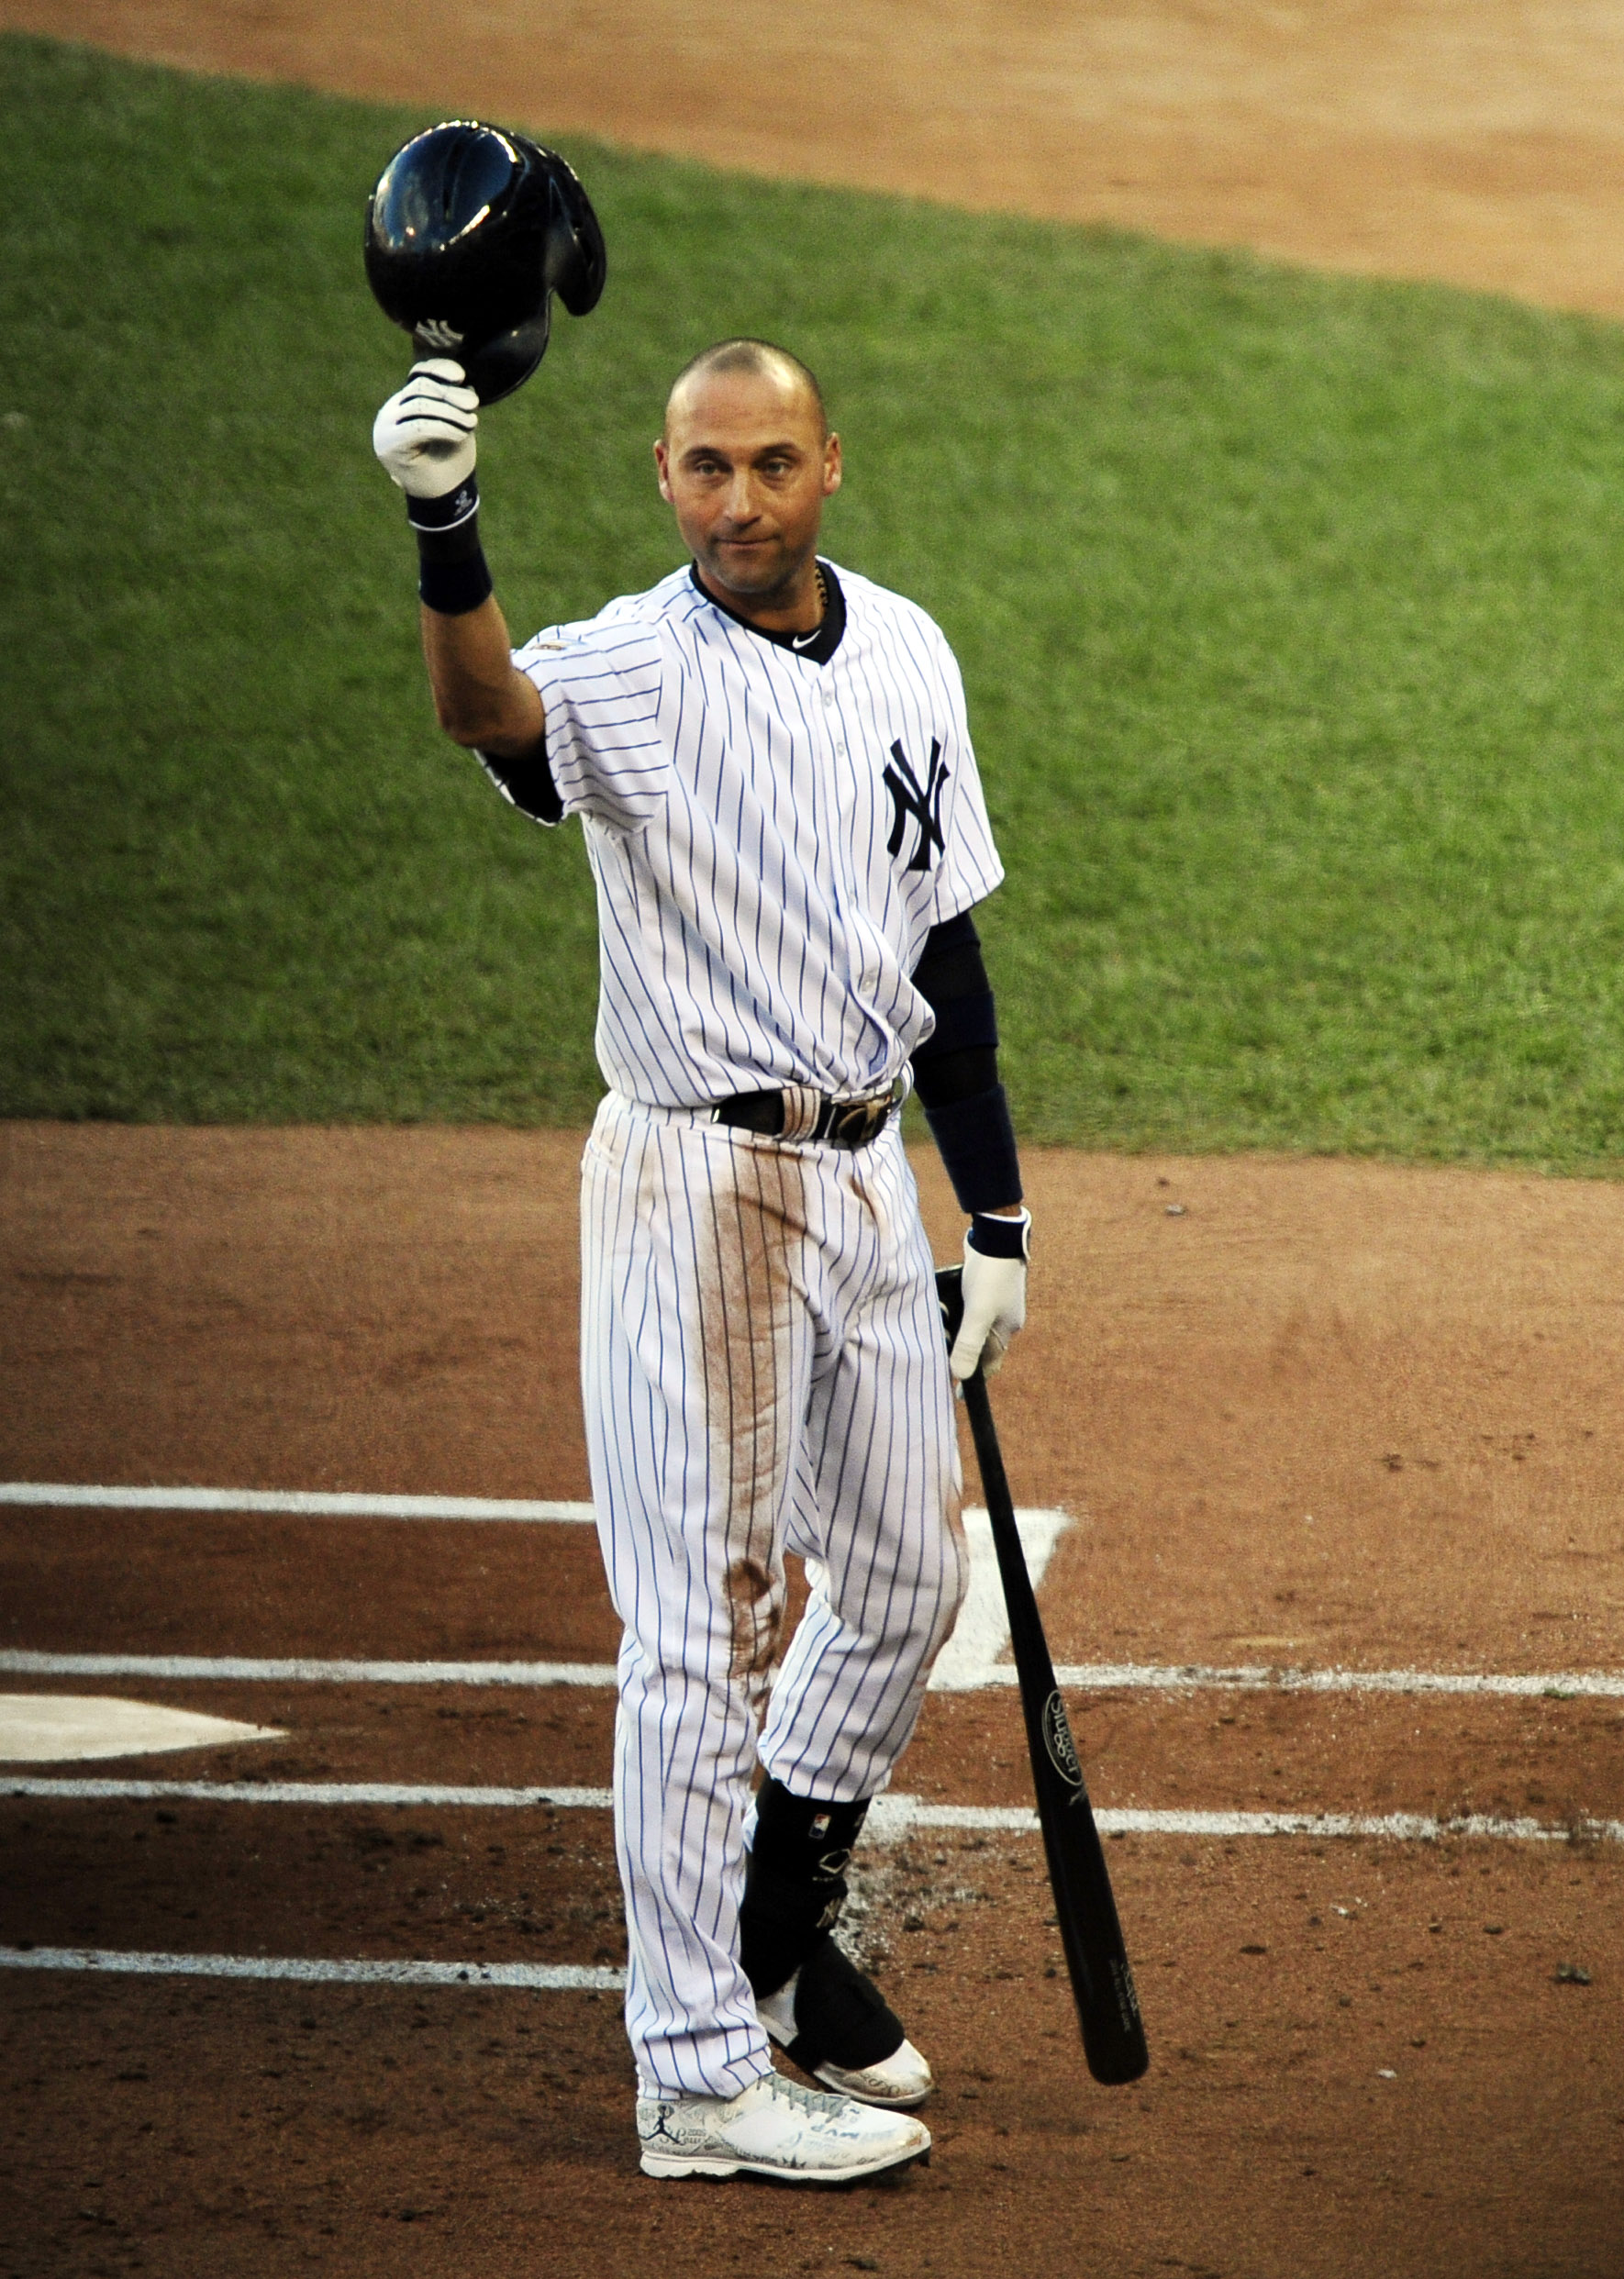
Jeter’s image is a huge reason why he is viewed as the captain. A simple Google search, shown to the right (Google Images), yields thousands of pictures of Jeter. Most of these pictures contain a smiling, charismatic looking guy or an intense athletic in-game shot of Jeter making a great play or hitting a homerun. The picture to the left is a picture taken by USA Today photographer Jeff Curry showing Jeter in his last All-Star Game appearance (Curry). He is standing tall and proud with his bat hanging in his left hand and his helmet tipped to the fans in a silent gesture of appreciation and thanks. The look on his face is one of subtle confidence as he prepares to step into the batters box he has become so familiar with over the years. This picture is a great representation of the cool confidence Jeter stands for to fans of baseball all over the world. Jeter is saying, in quiet and classy way that, ‘I appreciate you all, you are all on my team, and I’m going to get this one for you.’ Just from this image, even if someone had no idea who Derek Jeter was or what baseball even was, his body language speaks volumes, displaying the calm, cool Jeter many have come to love. It is the overwhelming bulk of these images that can consume audiences to see the positive light of Jeter. Jeter’s portrayal is that of a confident, cool individual.
While Jeter’s confident and cool nature shines through in images, his caring nature is also very apparent. He seems to have a great knowledge of the game and how to be successful. Jeter is able to be in the limelight without being unnerved or exposed negatively by it. He is then able to use that limelight to show his charitable side to his audience. In Jeter’s first interview with David Letterman as a young 22-year-old, after his rookie of the year award, his coolness and clam demeanor was apparent. When David Letterman asked Derek what he is going to do in the off-season, Derek responded,
“I want to start my own foundation…Anyone can give money to the community, but I sort of want to be involved a little bit” (Letterman).

This statement right away is enough to win the hearts of almost any viewer. It was interviews like this one that helped set the image of what Jeter would be for the next 19 seasons of his career. Jeter set a persona for himself early on of a cool, collected, caring ballplayer and doing that is what has helped lend to his successful career and positive image in the community. This interview is just one very solid example that gives people a well-rounded look at Jeter. They see his humor, care for the community, obvious skill set, and confident body language. David Letterman and Derek both were motivated to improve their ratings in their own individual ways with the interview. Derek definitely achieved that by letting viewers know he wasn’t only going to focus on baseball.
From these initial television appearances, Jeter expanded himself even more into different media markets. From appearances on sitcoms to movies to late night TV, Jeter has taken full advantage of additional audiences. Two of Jeter’s most memorable and notable TV appearances were when he hosted Saturday Night Live in 1998 and 2001 (IMDb). One of the most popular skits was called “Derek Jeter’s Taco Hole.” In this skit, Derek is the proud owner of northern New Jersey’s finest Mexican cuisine restaurant. While Jeter promotes his restaurant, popular SNL comedians and actors Will Ferrell, Jimmy Fallon, Maya Rudolph, and Dean Edwards sing a catchy and humorous Mexican jingle to the tune of the Beach Boys Kokomo (IMDb). By doing these appearances, Jeter is able to show his subtle humor and charisma in other areas than baseball. He also is seen being surrounded by these popular comedians, which in turn shows audiences that he is well liked by fellow well known celebrities. These additional appearances were a huge part in Jeter building himself and his audience. By showing himself in these more scripted and playful roles, Jeter is able to control what he is saying and remain polished to keep a positive image around his actions and roles. By poking fun at himself within the skit and episode as a whole, Jeter is able to show that he is not perfect but can make light of the situation. Showing this humorous side and ability to be playful allows viewers to connect more so with the Yankee shortstop. His on field actions were seen by many, but these guest appearances really lended to fans being able to see another facet of Jeter’s personality and allowed fans to connect with Jeter’s humor.
Using this connectivity and positive, successful, charismatic image, Jeter was able to build himself as a brand and help market other brands. Derek Jeter has appeared in numerous ad campaigns throughout his career in the MLB. These ad’s have helped not only appeal to the market the perspective companies are trying to reach but have helped Jeter continue to be visible to audiences and build his own brand. Through these ads, Jeter has become a brand and marketing strategy in and of himself. One of the more popular ad campaigns Jeter has been a part of is the Gillette ads in the early 2000’s that Jeter, Tiger Woods, and Roger Federer were all featured in. At that time, the three athletes were at or near the top of their sports respectively and all were representative of the cool, confident media favorites that Gillette wanted to target with their ads. One commercial shows Jeter walking down a city street to the tune of Stayin’ Alive by the Bee Gees. The camera starts on Jeter’s feet, which are sporting a pair of nice leather shoes. The camera pans up to show a sharply dressed Jeter with a smooth face, apparently from shaving with a Gillette razor. The camera then spans out a bit more, and Jeter meets up and fist bumps a sharply dressed Tiger Woods. They both then spot Federer across the street and laugh together at Federer because he is wearing a pair of shiny Italian heels. At the end of the commercial the words ‘Here’s to Confidence’ appear on the screen as Jeter and Woods walk out of the frame (Staying). This commercial uses the cool and confident manner that Jeter and other similar athletes at the time had built for themselves through their athletic achievement and prowess. Gillette knew that people saw these athletes as great examples of confidence. Gillette used that appeal to say their product helps give their consumers the same confidence as their favorite athletes. This also aided Jeter by very openly portraying him as that image of confidence and success. Even people more familiar with the Gillette brand than sports can see that they are portraying Jeter as a confident man who uses their product. Additionally, being placed in that type of commercial with other international sports stars allows Jeter to reach the fans of Woods and Federer. They see their favorite athletes walking along with Jeter and can draw connections with what they love about Federer or Woods with Jeter just by placing them together in the ad. This benefits Derek once again by building that network of supporters that transcends the baseball field.
Building a brand for a product also was a huge contributing factor to Jeter being able to build himself as a brand. This self-brand has been used in many other commercials and is especially evident in one of his latest Nike Jordan commercials called Re2pect. This Re2pect commercial for Nike Jordan aired towards the end of Jeter’s final season. The commercial shows Jeter doing his signature plate routine where he digs in his feet, which are sporting Jordan brand cleats, and tips and adjust his helmet. The rest of the commercial is a build of the Red Sox pitcher, Yankees fans, the New York Mets, police men, Tiger Woods, Jay-Z, a bellhop, a young baseball player, and many more people tipping their caps to “the Captain” before Michael Jordan is shown at the end tipping his Jordan brand cap to Jeter. Then, Jeter digs in once again and stares down the pitcher as he awaits the pitch. The commercial fades out with an image of New York City in the background as the phrase ‘RE2PECT’ flashes onto the screen. When spelling respect in the commercial, the ad makers replaced the S with the number 2 in honor of Jeter’s jersey number (Jordan). This commercial builds off of Jeter’s previous work. It is a reiteration to fans everywhere of that consistent image of a confident, respected captain figure to not only his team and Yankees fans, but the fans of baseball in general. By showing other teams and big rivals respecting Jeter as he approaches the plate, the commercial allows other fans to see that Jeter is to be respected. It consciously or subconsciously influences viewers to think Jeter is obviously deserving of praise just by seeing how everyone within the commercial respects him. This also lends to the Jordan brand by placing a few very well know professional athletes into one ad, suggesting to fans that people who wear Jordan are people who are successful.
These overwhelming discourses representing Jeter as a winning brand and marketing tool are not the only opinions out there. Some people do not consider Jeter to be the great athlete and persona that most of the previous sources paint him as. Derek Jeter, despite all the positive discourses, still has some people talking negatively about him. Not everyone thinks he is great or that his persona is a positive one. Blogger Joe Posnanski posted a less than positive blog on his site, called Joe Blog, about Jeter. Joe is a former Sports Illustrated columnist and is currently a sports journalist for NBC Sports. He maintains the blog to more freely portray his opinions. Posnanski posted about Jeter in May 2008 saying,
“Jeter brings out this quality in people, this superiority, this … it just drives me insane I don’t know if there’s a word for this quality so, as we do here, I’m going to invent a word. Jeterate (verb) meaning ‘to praise someone for something of which he or she is entirely unworthy of praise.’” (Posnanski).

This Joe Posnanski blog post obviously isn’t as big of a presence in the media as a David Letterman segment or a Jordan commercial, but it is interesting to see that there are people out there who think Jeter is unworthy of all the accolades he has gotten over his career. Joe may not draw a big audience, but his background with sports and his obvious success within sports writing help him carry a little bit more clout with what he says. Posnanski wants to like Jeter, but he just can’t bring himself to based on how Jeter brings out this ‘Jeterate’ attitude. This contrasting opinion is a great reminder that there are going to be critics out there no matter what. This blog may only reach a few people, but the fact that discourses like this are present gives a small sliver of doubt as to the overwhelmingly positive and successful persona of Derek Jeter. Posnanski is saying that this confidence that we have seen portrayed by commercials, images, and interviews is actually more of a cockiness.
Posnanski isn’t the only person who is less than thrilled with the former shortstop. Others have discounted Jeter because they say he is overrated on the field. His mediocre fielding range and lack of any huge numbers have been a constant source or negativity according to Andrew Conway, a columnist for a popular sports site called Next Impulse Sports. Conway lends Jeter’s success to those around him and says,
“Whether you want to believe Jeter was the benefactor of a ridiculous lineup for nearly two decades is up to you. Some of those seasons he had 40+ home run guys hitting in the lower third of the Yankees’ lineups. And yet with all of that help behind him, and netting 700+ plate appearances in 10 different seasons – five of which he led the league – Jeter only led the league in runs one time. Once. He led the league in hits just two times. He never accumulated 100+ walks. He never led the league in any other major statistical category” (Conway).

It is clear that Conway is using the statistics of Jeter’s career to show that he may not be all that he is hyped up to be. It is unique the way this rhetor detracts from Jeter using statistics in the same way many other rhetors use statistics to call him a great player. By discounting Jeter’s on field performance, Conway discounts Jeter in general. He takes away from the dominating image and pushes people to take a deeper look at his stats. Yes he had a good amount of hits and runs, but, in Conway’s opinion, he was bound to do that with the opportunities he was given. He had the most at bats of anyone in the league for 5 seasons. He had some of the best hitters in the league surrounding him in the lineup. Anyone could do well in that situation. These statistics and, more importantly, how they are framed can paint two very different pictures of Jeter.
Statistics, however, are not very revealing as to a persons real persona and life, and some people say Jeter hasn’t been very revealing in that sense. Despite being in the public light on the field for so long, some people think Jeter earned his reputation by being mysterious and limited. They believe he was able to keep a positive persona because he did not seem to show much else from his life outside of his on field performance. Will Lietch, another online sports columnist, highlighted this idea is his Sports on Earth article in which he says,
“He (Jeter) has lived in the public eye -- and the dead zero center of the public eye -- and given us nothing about himself” (Leitch).

Leitch is drawing upon the fact that Jeter has been able to keep a quiet life off the field, and thus hasn’t revealed much of anything to us. He isn’t saying whether this mystery is necessarily good or bad, but he says that by doing this, Jeter is able to avoid a lot of negativity. After all, it is hard to shed a bad light on somebody when you don’t know what to shed that light on. Despite the long career, numerous interviews and TV appearance, ad campaigns, and everything else that has kept Jeter front and center for a large audience, he has been able to avoid any major slip-ups or glimpses into who he is. It is very oxymoronic to have that happen, and Leitch, as well as many of his readers, is able to see this and start to ask questions. Everything seems to be very baseball centric for Jeter and that shields a lot of the visibility with what he is or isn’t doing off the field. What exactly has Jeter given people to judge himself upon? Is it Jeter’s polished appearance, or lack of appearances that has lead to the person people see Jeter as on his way into retirement? These are just a few of the questions Leitch seems to pose for audiences to ponder. In the end, what does all this lead to in terms of Derek Jeter’s persona?
Through discourse created by Jeter, and those surrounding him inside and outside of the mainstream media, a persona has grown. Most sources talk about the success Jeter has had and the positives of Jeter, but there are still a few that shed a bad light on the retired shortstop. It is apparent that the positives seem to outweigh the negatives when analyzing the discourses that have created “the Captain.” Thus, Derek Jeter still seems to maintain his desired image. Through media and discourse, Jeter’s coolness, confidence, charm, charity, and success shine despite the negatives cast upon him saying he is overrated and unrevealing. Time will definitely tell what the overall lasting image of Jeter will be. Right now it is hard to definitively say he will always be considered a great ballplayer with a great persona because, due to his recent retirement, a lot of people may be looking back with rose-tinted glasses. It is apparent however that the overwhelming message seems to portray Jeter as “the Captain” so many have come to know him as. This came about through the combination of positive images and quiet personality off the field. It will be interesting to see how Jeter is viewed down the road, but for now, I don’t think his successful image is going anywhere. For an era of baseball that has been darkened by performance enhancing drug scandals, Jeter has produced a small light to help disperse that darkness. The MLB and others have looked to him and his career as a prime example of somebody approaching and playing the game the right way. For many, including myself, Jeter represents what baseball should stand for and how professional athletes should carry themselves in general. Moving into the future, I believe Jeter’s image will be used to help show the next generation of profession baseball players that you do not need to cheat and taint the game of baseball to find success. After all, how else do you earn a nickname like “The Captain”?

Works Cited
Conway, Andrew. "Is Derek Jeter The Most Overrated Baseball Player Of All Time?" Next Impulse Sports. Next Impulse Sports, 18 Feb. 2014. Web. 20 Nov. 2014.
Curry, Jeff. Derek Jeter Tips His Helmet. 2014. USA Today. Web. 21 Nov. 2014.
"Derek Jeter." IMDb. IMDb.com, n.d. Web. 20 Nov. 2014.
"Google Images." Google Images. N.p., n.d. Web. 19 Nov. 2014.
Jordan. "RE2PECT." YouTube. YouTube, 14 July 2014. Web. 21 Nov. 2014.
Leitch, Will. "The Great Unknown." SportsonEarth.com. Sports on Earth, 29 May 2014. Web. 20 Nov. 2014.
Letterman, David. "Derek Jeter's First Appearance with David Letterman." Late Show with David Letterman. CBS. New York, New York, 18 Nov. 1996. Youtube. Web. 20 Nov. 2014. Transcript.
Posnanski, Joe. "I Wanna Like Derek Jeter! I Do!" Web blog post. Joeposnanski.com. Joe Posnanski, May 2008. Web. 20 Nov. 2014.
""Staying Alive" Feat Tiger Woods, Derek Jeter, Roger Federer." Dailymotion. Gillette, n.d. Web. 21 Nov. 2014.

Research Essay Reflection on the Revision Process
A couple major revisions I had within this draft were changing my sources and focuses for a couple points and smoothing out transitions between ideas. These revision ideas came from a few different meetings with Prof. MGM and fellow classmates.
For the source changes, I originally had a Youtube video of a few comedians paying tribute to Jeter, but I decided to change that to an SNL skit that had Jeter in it because I thought this would relay the point of connecting humor with Jeter. This humor had to be apparent and show how the humor was used to boost Jeter’s persona. The SNL skit provided a better means for that. The other source change involved switching out a Forbes branding article about Jeter to two ad campaigns that involve Jeter. This helped focus in more on how Jeter was built up and visible to the world through these different ads. The Forbes article was more focused on the fact that Jeter had become a brand than the actual ads that helped make Jeter into a brand.
In terms of transitions, I originally had some rough patches within the essay. Most of my transition sentences were at the ends of paragraphs instead of the beginnings. The flow also wasn’t great with these transitions, so I decided to rework them and position them at the beginning of each paragraph.
I am very pleased with my revision in the area of overall content and connectivity of different ideas to show how and why Jeter is seen the way he is. I also am very happy with how my ideas came together to fit a very solid thesis statement and allow me to come up with a very well thought out conclusion about Jeter’s effect on the game of baseball.
I struggled a lot with finding negative sources at first, but once I found a few, I was able to draw out some specific things that took away from the positive persona of Jeter. It was difficult to find and write about these, however, just because they are contrasting and few and far between. I also struggled a bit with remaining analytical versus biographical or too opinionated about the essay.
My final thoughts are that this was an enjoyable essay to write; it just took a little self-pushing to get started and get finished with the assignment. Overall, I think that analyzing this type of thing definitely lended to my ability to delve a bit deeper into why things are the way they are.

